# Level: Difficult

1. Number Matrix

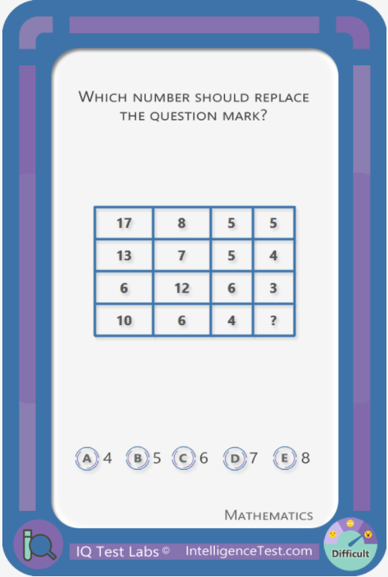

Candidates: 4, 5, 6, 7, 8

Hint: For each row, add the numbers in the first two columns.

Solution: 4

2. Number Matrix

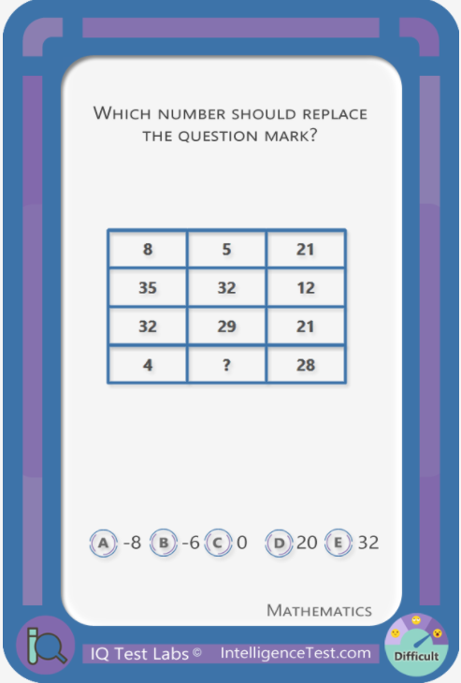

Candidates: -8, -6, 0, 20, 32

Hint: For each row, the third column involved calculating the sum of the digits.

Solution: -6

3. Days of the week

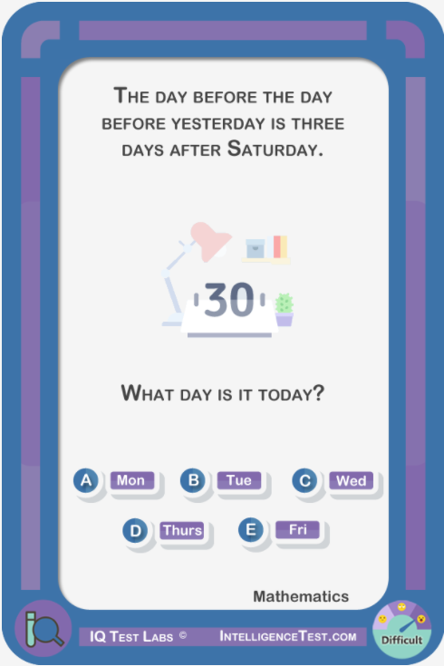

Candidates: Monday, Tuesday, Wednesday, Thursday, Friday

Hint: Three days after Saturday is Tuesday

Solution: Friday

4. Marbles

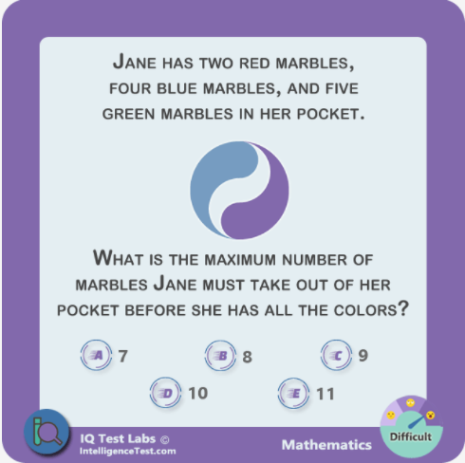

Candidates: 7, 8, 9, 10, 11

Hint: If Jane had just two red marbles and one blue marble, she would have to take all marbles out of her pocket to make sure she has at least one of each color.

Solution:

Solution: 10

5. Find the missing number

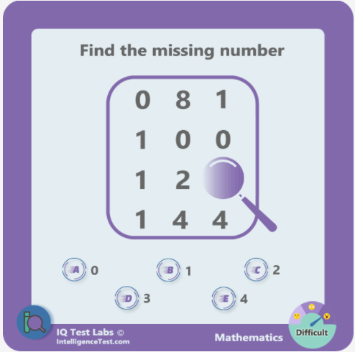

Candidates: 0, 1, 2, 3, 4

Hint: Main operation involved is multiplication

Solution: 1

6. Fractions

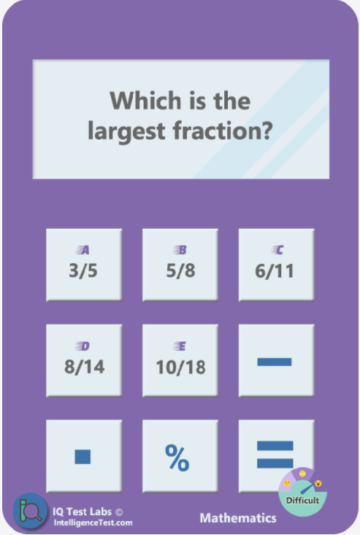

Candidates: ⅗, ⅝, 6/11, 8/14, 10/18

Hint: The lowest fraction is 6/11 (0.54545)

The second highest fraction is ⅗ (0.6)

Solution: ⅝

7. Soccer competition

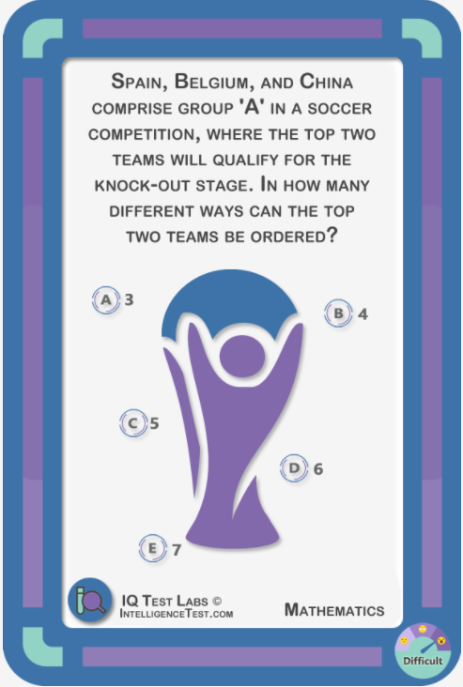

Candidates: 3, 4, 5, 6, 7

Hint: This calculation involves permutations, and order is relevant.

Some (or all) of the permutations are: Spain/Belgium, Spain/China, Belgium/Spain, Belgium/China, China/Spain

Solution: 6

8. Arranging letters

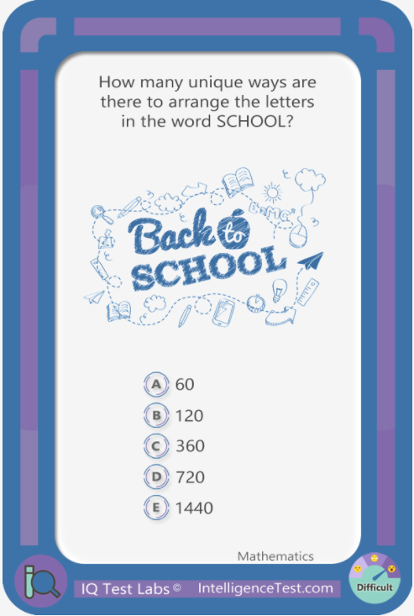

Candidates: 60, 120, 360, 720, 1440

Hint: Use the formula for permutations since the position of the letters matters.

In some permutations the letters 'O' are side by side. 'OO' is the same whichever 'O' is first.

Solution: 360

9. Probability hat

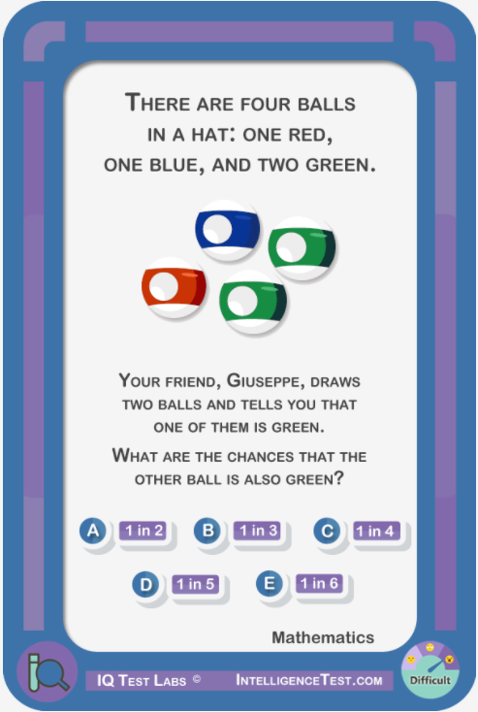

Candidates: 1 in 2, 1 in 3, 1 in 4, 1 in 5, 1 in 6

Hint: Total possible options for the retrieved balls are:

G1G2, G1B, G1R, G2G1, G2B, G2R, BG1, BG2, BR, RG1, RG2, RB

Solution: 1 in 5

10. Calendar



Candidates: 51, 52, 53, 54, 55

Hints: 365/7 is not exactly 52.

It is possible to have two Sundays in eight days.

Solution: 53

# Level: Medium

1. Number Series

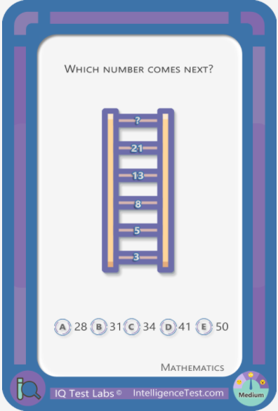

Candidates: 28, 31, 34, 41, 50

Hint: One method of solving includes addition

Answer: 34

1. Number series

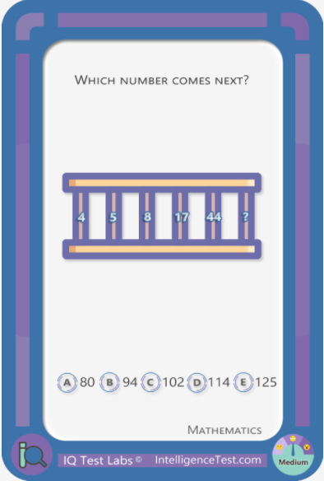

Candidates: 80, 94, 102, 114, 125

Hint: First step: calculate the difference between the numbers

Answer: 125

1. Number series

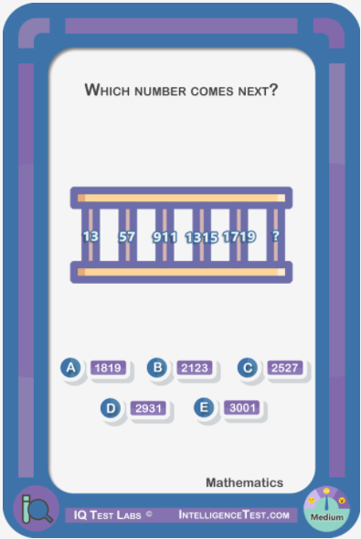

Candidates: 1819, 2123, 2527, 2931, 3001

Hint: This is a progression of odd numbers

Answer: 2123

1. Handshakes

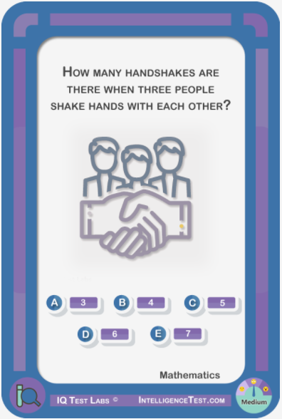

Candidates: 3, 4, 5, 6, 7

Hint: Order doesn't matter. 'A' shaking hands with 'B', is the same handshake as 'B' shaking hands with 'A'.

Answer: 3

1. Cookies

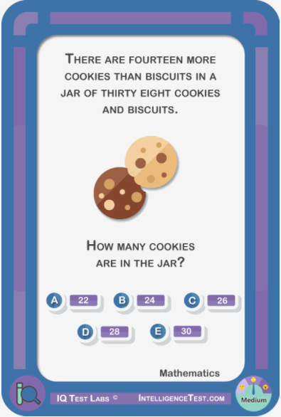

Candidates: 22, 24, 26, 28, 30

Hint: Try solving equations, where 'C' is cookies and 'B' is biscuits. One equation is: C + B = 38.

Answer: 26

1. Fractions

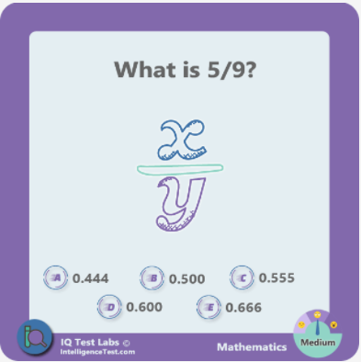

Candidates: 0.444, 0.500, 0.555, 0.600, 0.666

Hint: 500/900 may make the division easier

Answer: 0.555

1. Number puzzle

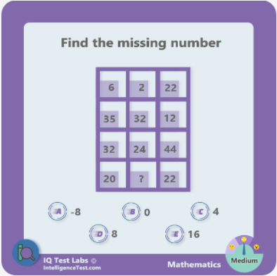

Candidates: -8, 0, 4, 8, 16

Hint: For each row, Column B should be subtracted from Column A.

Answer: 16

1. Number puzzle

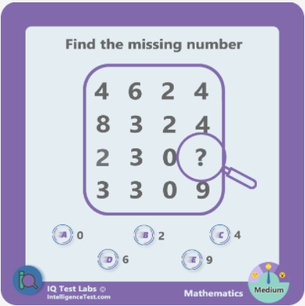

Candidates: 0, 2, 4, 6, 9

Hint: The main operation involved is multiplication

Answer: 6

1. Cars and trucks

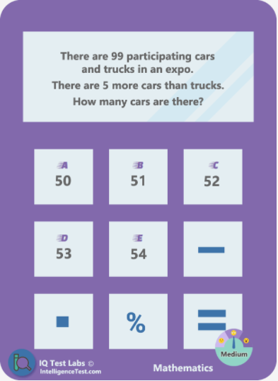

Candidates: 50, 51, 52, 53, 54

Hint: Try solving equations, where ‘C’ is cars and ‘T’ is trucks. One question is: C - T = 5

Answer: 52

1. Averages

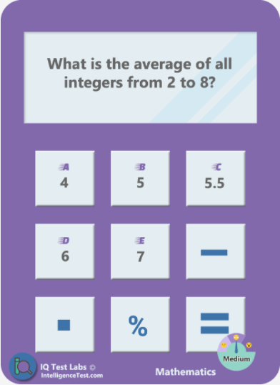

Candidates: 4, 5, 5.5, 6, 7

Hint: Shortcut: for a series of consecutive numbers with a odd number of terms, the mean and the median are the same

Answer: 5

1. Averages

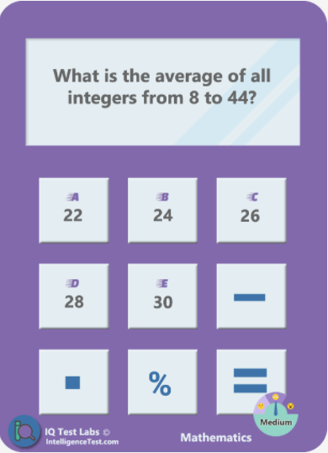

Candidates: 22, 24, 26, 28, 30

Hint1: There is a formula for determining the average of a long series of consecutive numbers.

The first part of this formula consists of adding the first and last numbers.

Hint2: The sum of the first/last numbers is 52, and the answer options are

22-24-26-28-30. What would the second part of the formula most likely be?

Answer: 26

1. Percentages

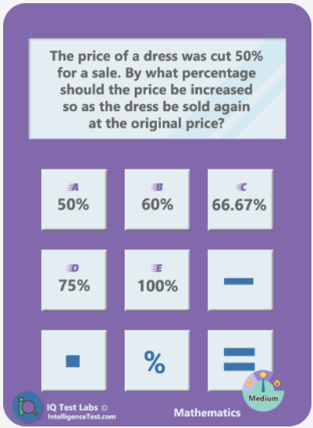

Candidates: 50%, 60%, 66.67%, 75%, 100%

Hint: Substitute smaller values such as $2 or $10

Answer: 100%

1. Intersecting circles

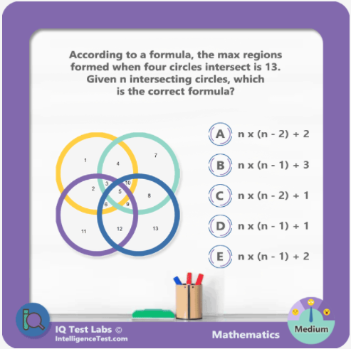

Candidates: n x (n - 2) + 2, n x (n - 1) + 3, n x (n - 2) + 1, n x (n - 1) + 1, n x (n - 1) + 2

Hint: Substitute ‘n’ for the number 4 for each of the answer choices

Answer: n x (n - 1) + 1

1. Soccer competition

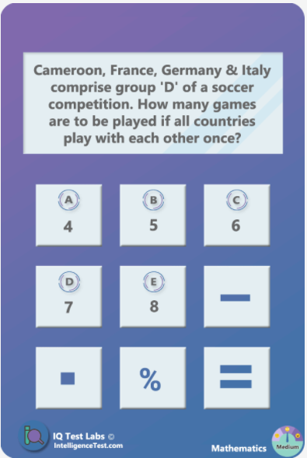

Candidates: 4, 5, 6, 7, 8

Hint: This is a combinations question where order is not important

Answer: 6

1. Park bench

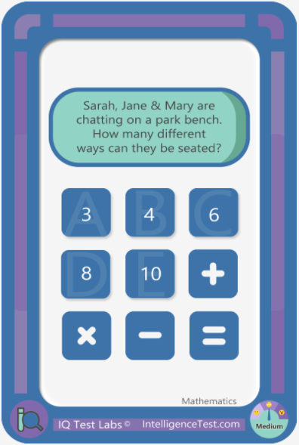

Candidates: 3, 4, 6, 8, 10

Hint: This calculation involves permutations, where order is relevant

Answer: 6

1. Outfits

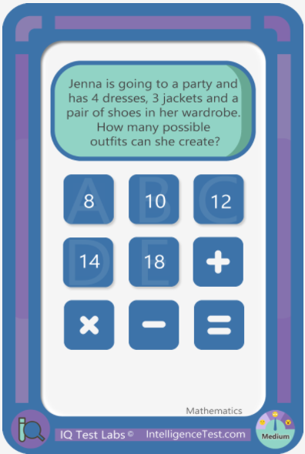

Candidates: 8, 10, 12, 14, 16

Hint: The fundamental counting rule states that if there are 'p' ways of doing one thing and 'q' ways of doing another, then the total number of possible outcomes is p x q.

Answer: 12

1. Spinner

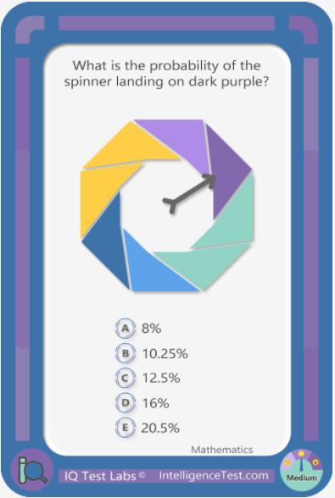

Candidates: 8%, 10.25%, 12.5%, 16%, 20.5%

Hint: There is more than 10% chance.

Answer: 12.5%

1. Spinner

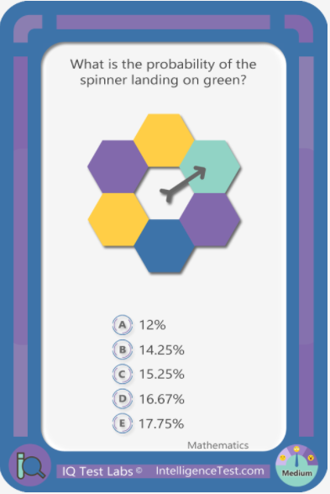

Candidates: 12%, 14.25%, 15.25%, 16.67%, 17.75%

Hint: There is more than 15% chance

Answer: 16.67%

1. Surfing

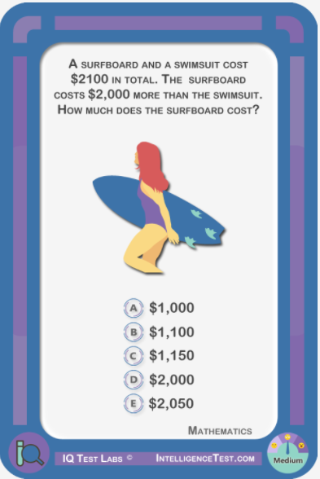

Candidates: $1000, $1100, $1150, $2000, $2050

Hint: The surfboard costs $2000 more than the swimsuit.

Answer: $2050

1. Number series

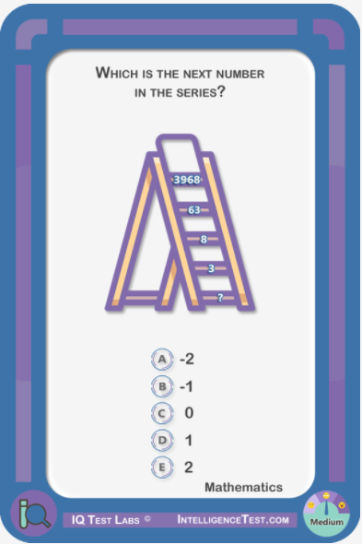

Candidates: -2, -1, 0, 1, 2

Hint1: Mathematical operations include addition and square root.

Hint2: One of the calculations is, (8+1) = 3

Answer: 2

1. Fractions

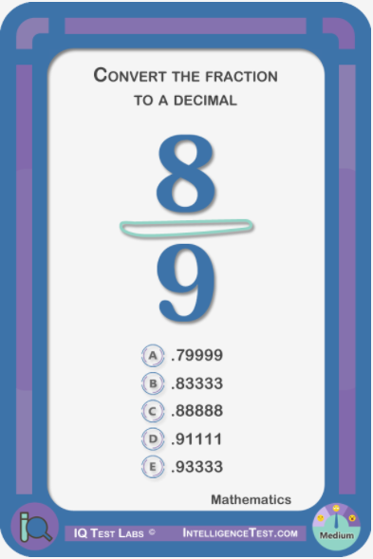

Candidates: .79999, .83333, .88888, .91111, .93333

Hint1: More than 0.8

Hint2: Less than 0.9

Answer: .88888

1. Fractions

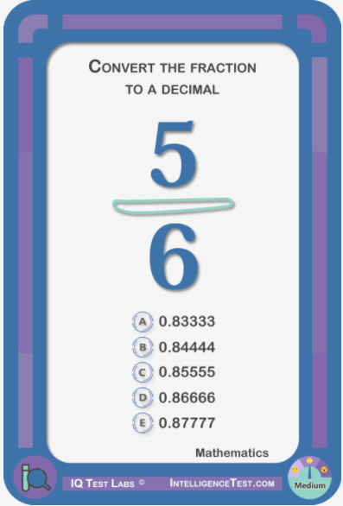

Candidates: 0.83333, 0.84444, 0.85555, 0.86666, 0.87777

Hint1: Less than 0.87777

Hint2: Less than 0.85555

Answer: 0.83333

1. Sandcastle

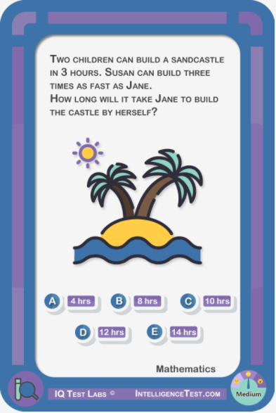

Candidates: 4, 8, 10, 12, 14

Hint1: Jane’s rate + Susan’s rate = 1/3

Hint2: Susan’s rate is three times that of Jane’s rate. r + 3r = 1/3

Answer: 12

1. Construction workers

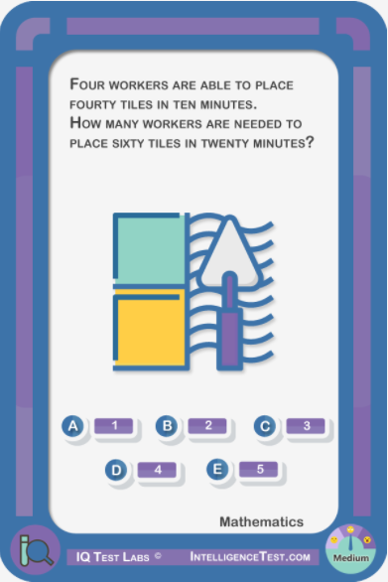

Candidates: 1, 2, 3, 4, 5

Hint1: For four workers, the rate of placing tiles is four tiles per minute.

Hint2: One worker will place twenty tiles in twenty minutes

Answer: 3

1. Volume of a cube

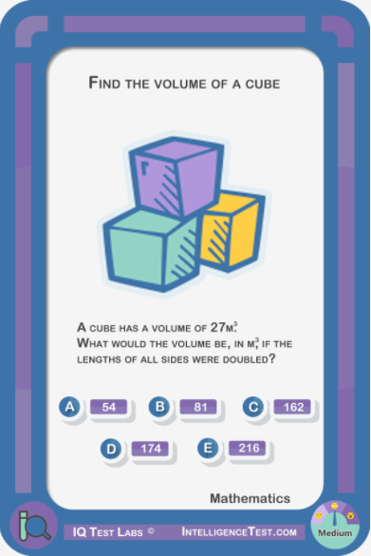

Candidates: 54, 81, 162, 216, 729

Hint1: Only one side is required to calculate the volume of a cube.

Hint2: It makes no difference which side is labeled length, height or width

Answer: 216

1. Digit matrix

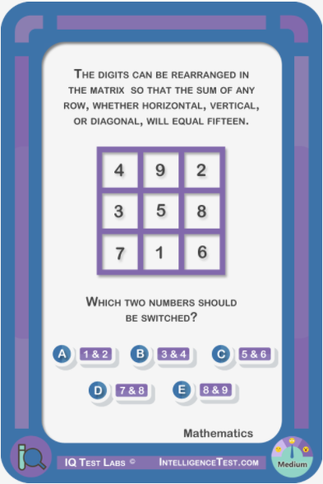

Candidates: A, B, C, D, E

Hint1: Any two numbers are as likely as the rest, as the difference between the numbers in the answer options is always one.

Hint2: Surest way to approach question is via trial and error

Answer: D

# Level: Easy

1. Number series

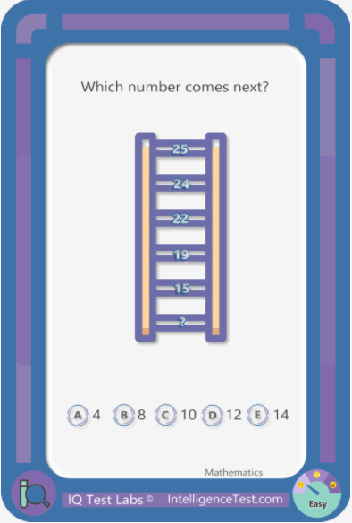

Candidates: 4, 8, 10, 12, 14

Hint: Pattern decreases continuously

Answer: 10

1. Number series

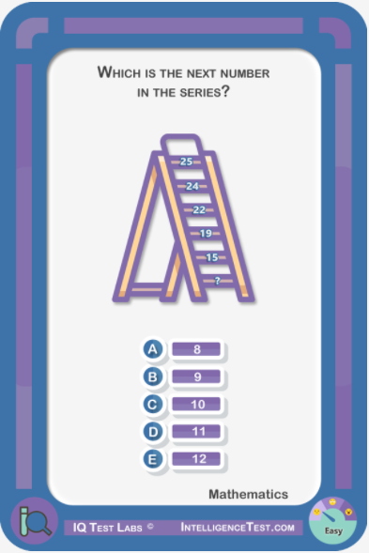

Candidates: 8, 9, 10, 11, 12

Hint1: Use subtraction

Answer: 10

1. Number series

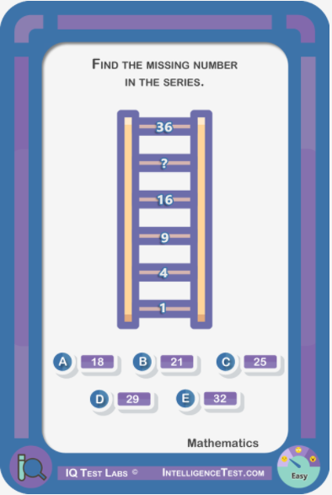

Candidates: 18, 21, 25, 29, 32

Hint: Squares are involved

Answer: 25

1. Number series

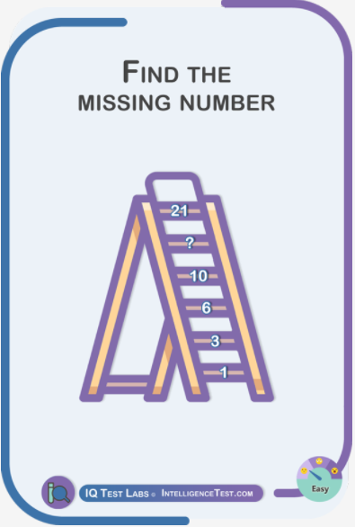

Candidates: 12, 13, 15, 16, 18

Hint1: The seventh number is 28

Hint2: The eight number is 36

Answer: 15

# Level: Mix

1.

A football field is 100 yards and also includes two endzones that are 10 yards long each. How many feet long is a football field including the endzones?

Candidates: 360, 300, 220, 320

Answer: 360

2.

Mike had a jar of nickels that had five more nickels than he originally thought. If the total amount of nickels was $4.35, how many nickels did Mike think he had originally?

Candidates: 78, 72, 82, 87, 86

Answer: 82

3.

How many exact pairs are there: 5656/5656 3458/3468, 5239/5239, 8967/8967, 1432/1432

Candidates: 6, 1, 4, 3

Answer: 4

4.

How many ounces are in a pound and a half?

Candidates: 24, 18, 16, 32

Answer: 24

5.

Joseph gets married next month. One year ago from the date he will get married, Joseph was in the Hamptons for the 4th of July. What month is it?

Candidates: July, June, May, August, March

Answer: June

6.

The bill is $14.23 and you pay with a $20. How much should you get back in change?

Candidates: $5.77, $4.16, $6.43, $2.50

Answer: $5.77

7.

Which number is largest?

Candidates: 14,000, 140.00, 1.400, 14.000, 14.00

Answer: 14,000

8.

There are 12 more toy cars than toy trucks in a toy box with a total of 38 toy cars and trucks. How many toy trucks are in the toy box?

Candidates: 23, 11, 13, 12, 26

Answer: 13

9.

Mike is 11 years old. Jim is twice as old as Mike. When Jim is 50 years old, how old will Mike be?

Candidates: 39, 38, 40, 41

Answer: 39

10.

An oven can cook 3 thin crust pizzas in an hour or 1 deep dish pizza in a hour. If you have one oven, how much time do you need to make 12 thin crust pizzas and 4 deep dish pizzas?

Candidates: 10 hours, 3 hours, 6 hours, 8 hours

Answer: 8 hours

11.

There are 4 times as many used cars in the car dealership lot as there as new cars. There are 120 cars total in the dealership lot. How many new cars are in the car dealership lot?

Candidates: 26, 27, 25, 24

Answer: 24

12.

A girl is 21 years old and her brother is a third her age. When the girl is 36, what will be the age of her brother?

Candidates: 22, 12, 27, 17

Answer: 22

13.

a 1/4 of an inch is equal to ___ inches

Candidates: 0.14, 0.2, 0.24, 0.1

Answer: 0.25

14.

You want to leave a 15% tip on a $33 meal. What is the total cost for the night?

Candidates: $38.45, $36.20, $34.50, $37.95

Answer: $37.95

15.

Louis makes $4638.34 a month. If $345.12 is taken out in taxes, what percentage has been removed?

Candidates: 9.80%, 3.90%, 13.20%, 7.40%

Answer: 7.40%

16.

Mary got a raise of 2% on her salary. If her original salary was $160000, how much is it after the raise is implemented?

Candidates: $166,600, $164,500, $168,600, $163,200

Answer: $163,200

17

How much square footage is there in a room that is 13 x 18 ft?

Candidates: 234 sq ft, 210 sq ft, 184 sq ft, 224 sq ft

Answer: 234 sq ft

18

You and 3 friends went out for dinner. The bill is $85.36. How much does each person owe?

Candidates: $21.34, $28.45, $23.54, $19.36

Answer: $21.34

19.

If sales tax is 6% and you buy a shirt for $25 how much do you owe?

Candidates: $2.25, $26.50, $27.00, $1.50

Answer: $26.50

20.

A race car travels 100 feet in .5 seconds. At this rate of speed, how many feet will the race car travel in a minute?

Candidates: 16,000 feet, 15,000 feet, 11,000 feet, 12,000 feet

Answer: 12,000 feet

21.

The bill is for $19.56 and you pay $50.01. How much change should you get?

Candidates: $30.45, $32.98, $20.19, $25.61

Answer: $30.45

22.

To make a dozen cookies Trish needs 1/4 cup of butter. She wants to make 9 dozen cookies. How much butter does she need?

Candidates: 2 ½ cups, 2 ¼ cups, 2 cups, 3 cups

Answer: 2 ¼ cups

23.

Mark got a 20% raise for his salary. If this salary was $1,800, what is his new salary?

Candidates: $2160, $2800, $1820, $2000

Answer: $2160

24.

Instructions for a blanket call for 36 yards of yarn. A skein of yarn has 6 feet in. How many skeins of yarn do you need?

Candidates: 12, 20, 18, 23

Answer: 18

25.

A biker travels 5 feet in 0.5 seconds. At this exact speed, how far will the biker travel in a minute?

Candidates: 600 feet, 300 feet, 400 feet, 900 feet

Answer: 600 feet

26.

If rent is $1238 a month how much will you owe for 6 months?

Candidates: $7428, $9234, $14856, $2390

Answer: $7428

27.

A turkey was cooked at 400° F in the oven for 3 hours. The internal temperature rose from 30° F to 156° F. What was the average rise in temperature per hour?

Candidates: 40.3, 36, 44, 31, 42

Answer: 42

28.

The square footage of a room is 1400 feet. If the one side is 25 ft long, what is the lenth of the other side?

Candidates: 56, 32, 23, 45

Answer: 56

29.

A store buys a pack of gum for 33 cents per pack from their supplier. How much would 12 packs cost?

Candidates: $6.39, $6.93, $3.69, $3.96

Answer: $3.96

30

There are how many inches in 17.5 feet?

Candidates: 225, 175, 210, 190

Answer: 210

31.

If cookies sell for $1 and oranges for 75 cents, how many of each were sold for a total of $8.25?

Candidates: 1 orange and 7 cookies, 8 oranges, 3 oranges and 6 cookies, 2 oranges and 9 cookies

Answer: 3 oranges and 6 cookies

32.

A copy machine repairman makes $12.50 per hour plus $4 for every service call he performs. Last week he worked 34 hours and made 6 service calls. How much money did he make?

Candidates: $449, $601, $512, $396

Answer: $449

33.

On Tuesday and Wednesday, cab fare cost $7.75 total. On Monday and Thursday, cab fare cost $6.30 on each day. On Friday, cab fare cost $7.00. What was the average daily cost?

Candidates: $5.35, $7.10, $7.02, $5.47, $6.05

Answer: $5.47

34.

The volume of a room that is 23 feet in W, 10 feet in D, and 8 feet in H is:

Candidates: 1840 cubic ft, 2000 cubic ft, 1684 cubic ft, 1200 cubic ft

Answer: 1840 cubic ft

35.

What is the next number in this sequence?

41, 29, 35, 23

Candidates: 29, 27, 30, 31

Answer: 29

36.

Martha and Steve have 95 colored pencils. If martha has 4 times as many as steve, how many does Steve have?

Candidates: 14, 16, 23, 19

Answer: 19

37.

If the location you want to go is 270 miles away and you want to get there in 4.5 hours, at what constant speed do you need to drive at?

Candidates: 80 mph, 75 mph, 60 mph, 50 mph

Answer: 60 mph

38.

Max makes $3000 a month. He puts 15% in savings each month. After a year how much would he have in savings?

Candidates: $3600, $5400, $2800, $6200

Answer: $5400

39.

There are 3 times more caramel chocolates in a box comprised of caramel chocolates and chocolates with nuts. How many are there of each if there are 20 chocolates

Candidates: 12 caramel and 8 with nuts, 18 caramel and 2 with nuts, 9 caramel and 2 with nuts, 15 caramel and 5 with nuts

Answer: 15 caramel and 5 with nuts

40.

Frankie wants a tattoo that will take 5 hours to complete. If the artist charges $85 a hour for the first three hours and half price for every hour after, how much will it cost?

Candidates: 13 feet, 16 feet, 12 feet, 14 feet

Answer: 13 feet

41.

A store owner bought some flower pots for $1,200. The flower pots were sold for $2,700, with a profit of $30 per pot. How many flower pots did she sell?

Candidates: 48, 47, 49, 50

Answer: 50

42.

A new phone sells for $250 and a used one sells for $75. How many of each are sold if the profit for the day is $625

Candidates: 3 new phones, 1 new phone and 5 used, 9 used phones, 2 new phones and 2 used ones

Answer: 1 new phone and 5 used

43.

A lawyer owns 4 pairs of pants, 5 dress shirts and 6 ties. How many days can the lawyer go without wearing the same combination of three items?

Candidates: 120, 26, 15, 34

Answer: 120

44.

If it takes 2 minutes to make it through the circuit and Josh is number 32 in line, how long will it be until he is done?

Candidates: 2 hours, 1 hour and 4 minutes, 45 minutes, 1 hour and 30 minutes

Answer: 1 hour and 4 minutes

45.

A basketball team has eight boys and four girls on the roster. The boys average 12 points each. The team averages 136 points as a whole. How many points does each girl average?

Candidates: 14 points, 11 points, 12 points, 10 points.

Answer: 10 points

46.

There are 40 grams of sugar in a 12 oz can of Dr Pepper. If your max intake of sugar permitted for the day is 25 grams, how much of the Dr. Pepper can you drink?

Candidates: 2 oz, 6 oz, 12 oz, 7.5 oz

Answer: 7.5 oz

47.

Sally wants 3 dozen peanut butter cookies, 4 dozen snickerdoodles, and a dozen chocolate chip cookies. How many cookies are that?

Candidates: 120, 34, 200, 96

Answer: 96

48.

A road construction crew is resurfacing the highway between point D and point E. The distance between point D and point E is 93 miles of road. The crew has completed 35 miles. If they work at a pace of 2.9 miles per day, how many more days will it take to finish?

Candidates: 17, 15, 20, 22

Answer: 20

49.

A marathon is 26.2 miles. If Sally ran a marathon in 3 hours and 3 minutes, what was her approximate pace?

Candidates: 9 minutes, 10 minutes, 8 minutes, 7 minutes

Answer: 7 minutes

50. Handshakes



Candidates: 4, 5, 6, 7, 8

Hint: Not 8

Answer: 6

51. Days of the week



Candidates: Monday, Tuesday, Thursday, Friday, Saturday

Hint: Not Thursday

Answer: Friday

52. Numbers analogy

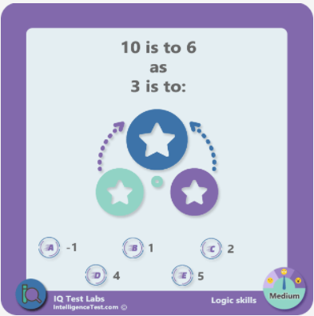

Candidates: -1, 1, 2, 4, 5

Hint: Not 4

Answer: -1

53. Analogy



Candidates: Lead, Love, Loop, Auras, Abode

Hint: Not lead

Answer: Love

54. Analogy



Candidates: Binding, Copy, Page, Cover, Bookmark

Hint: Not cover

Answer: Page

55. Objects series

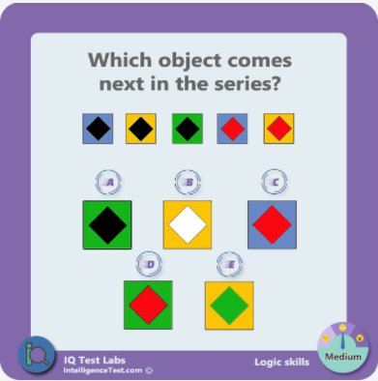

Candidates: A, B, C, D, E

Hint: Not A

Answer: D

56. Objects series



Candidates: A, B, C, D, E

Hint: Not A or B

Answer: C

57. Syllogism

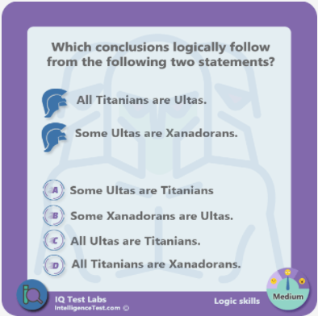

Candidates: A and B, A and C, A and D, B and D, B and C

Hint: More than one conclusion follows logically

Answer: A and B

58. Syllogism

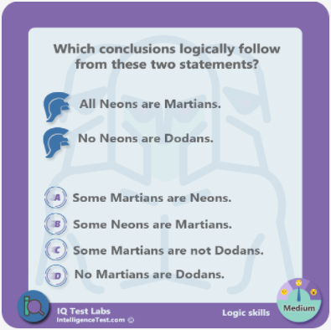

Candidates: Only A, Only B, Only C, A, B and C, A, B and D

Hint: More than two conclusions logically follow

Answer: A, B and C

59. Syllogism

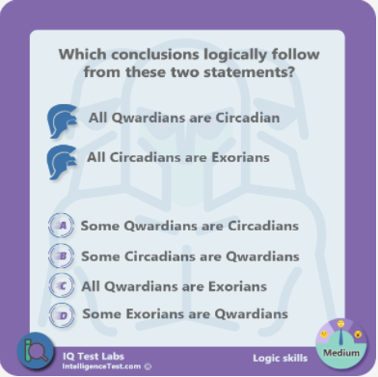

Candidates: Only A,

Only A & C,

Only A, B & C,

Only A, B & D,

A, B, C & D

Hint: At least 3 conclusions logically follow

Answer: A, B, C & D

60. Tic-tac-toe



Candidates: Yes, No

Hint: Assuming best play by both players, the first move always wins or draws.

Answer: Yes

62. Letter series

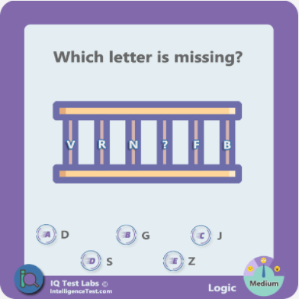

Candidates: D, G, J, S, Z

Hint: Notice the intervals between the letters when they are in alphabetical order

Answer: J

63. Letter series

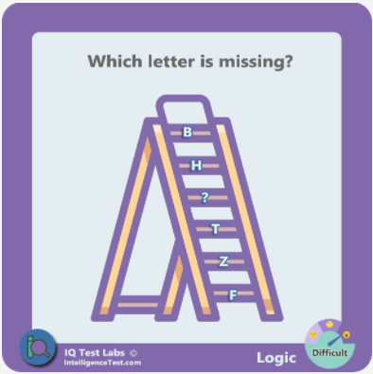

Candidates: A, E, N, X, Y

Hint: Place the letters in alphabetical order and note the intervals between them.

Answer: N

64. Team rank

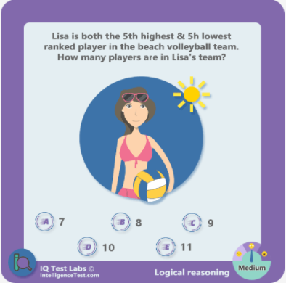

Candidates: 7, 8, 9, 10, 11

Hint: Try with smaller numbers. For example a player can be 2nd highest and 2nd lowest in a team of 3 players

Answer: 9

65. Earrings

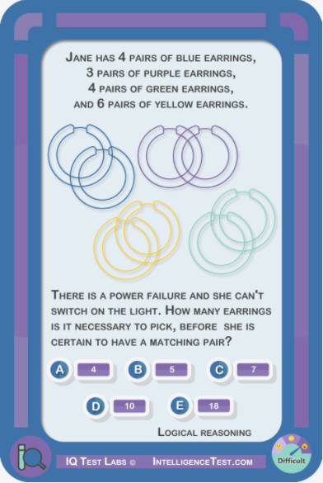

Candidates: 4, 5, 7, 10, 18

Hint: There are no left and right earrings, they are all the same

Answer: 5